Data collection form for Ukrainian after school group September 2024
Basic information
Name: |  |  |  |  |  | Date of birth:
School: |  |  |  |  |  | School year:
Parent/Carer
Name: |  |  |  |  | Relationship to young person:
Address:
Phone number: |  |  | Email address:
Medical details
GP/surgery name and address:
GP/surgery phone number:
Allergies:
Medical condition(s):

Consent form
Please tick (✅)
I give consent for ……………………………….. to:
- attend the sessions at 17, Broad Street, Bury BL9 0DA from 16:00 to 17:30 on Wednesdays.
- return home independently after the session (Key Stage 3 and 4 only).
If you do not consent to this, or if your child is in Key Stage 2, please give the name and contact details of the adult collecting the young person below.

Name: Phone number:

I have read and understood the data protection statement.

Signed: ……………………………………………………………………(parent/carer) Date: …………………………………..
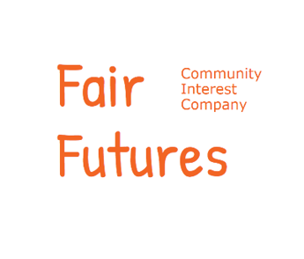
Fair Futures CIC – Photo permission
Name of young person …………………………………………………………………………………………………..……………………………

Fair Futures would like to use photographs/videos of the young people involved in the Children’s Ukrainian Club.
These images may be used for educational training and marketing purposes for Fair Futures and North West Regional Strategic Migration Partnership (RSMP). They may be featured on the Fair Futures website. These images may also be used for communication purposes and included in Fair Futures or RSMP publications.
To comply with the Data Protection Act 2018 Fair Futures requires your permission to use any images taken for the above purposes. We will not use the images taken, or any other information you provide, for any other purpose.

Name of parent/ carer …………………………………………………………………………………

I grant permission for photographs/videos of …………………………………………... (name of child) to be used for:
(Please tick as appropriate):

Fair Futures and Bury Metropolitan Council’s website (including Social Media)

Media Communications (e.g. Fair Futures and RSMP press releases)

Publications (e.g. newsletters, brochures, flyers)

All of the above

I do not give permission for photographs/videos to be used for any purpose

Please note that websites can be seen throughout the world, and not just in the United Kingdom, where the UK law applies.

I have read and understood the conditions of this consent form.

Parent/carer signature ……………………………………………………… Date ………………………..

Name (block capitals) ………………………………………………………………………………………………

Data Protection Statement

The information provided on this form by you is required by Fair Futures CIC in order to assess the needs of the young person attending the social club and to keep them safe. When we collect this information, we are required to comply with the General Data Protection Regulation (GDPR).
We will process this information on the legal basis that it is necessary for our work.
We will not share the information on this form unless required to do so as part of our work with this group or to comply with safeguarding protocol.
If you need any other information on how we process information, please contact the organisation directly.
Signed consent to data collection and retention

Parent/carer signature ……………………………………………………… Date ………………………..
Name (block capitals) ………………………………………………………………………………………………

